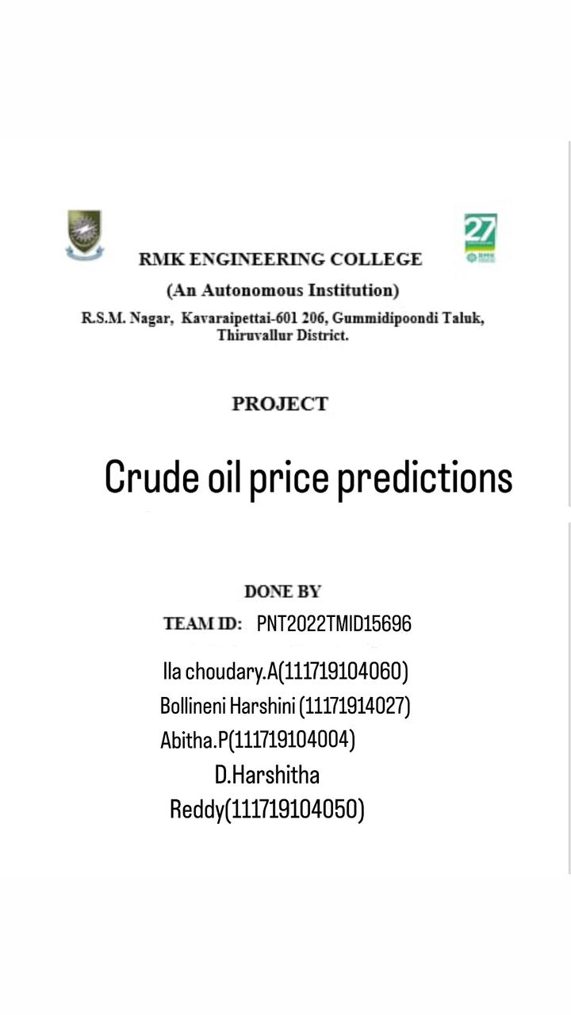

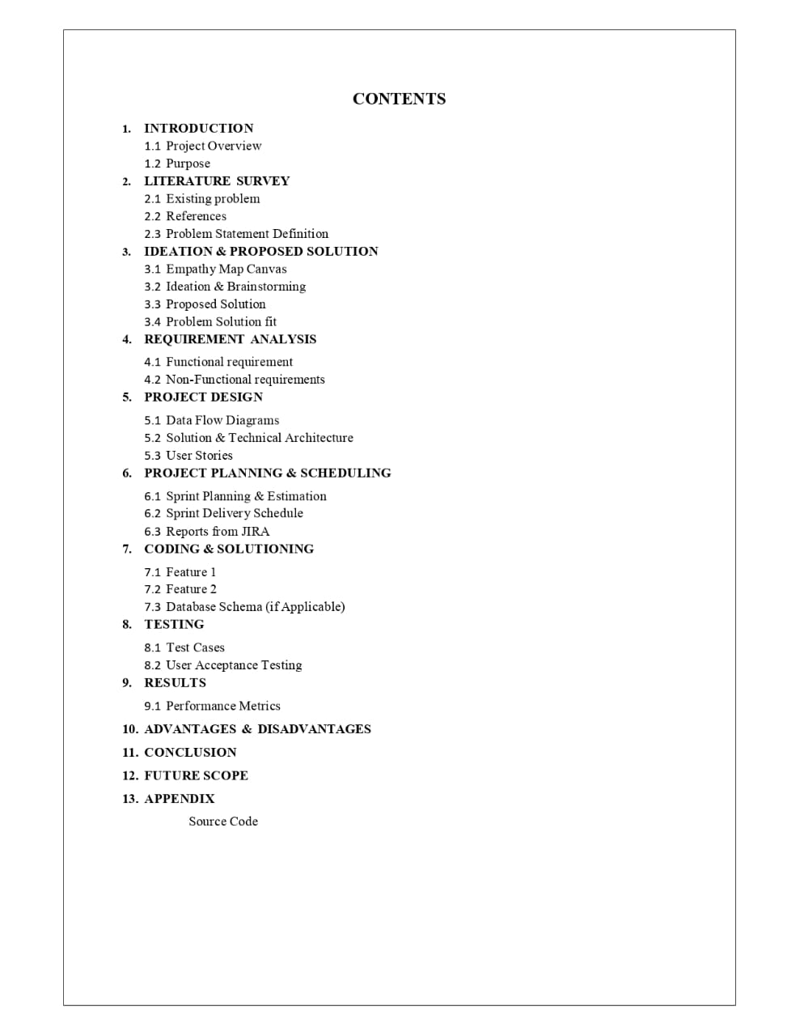

# INTRODUCTION

## Project Overview

Crude oil is one of the most important energy resources on earth. So far, it remains the world's leading fuel, with nearly one-third of global energy consumption.

Crude oil prices are determined by many factors and have a big impact on the global environment and economy. Although crude oil prices were firm in early 2014, they fell sharply from mid-2014.

In January 2016, the [U.S.](https://www.sciencedirect.com/topics/earth-and-planetary-sciences/united-states-of-america) refiner acquisition cost for crude oil imports, as a proxy for world oil price, is only $28.81 per barrel on average, and the West Texas Intermediate (WTI) crude oil spot price, as the benchmark oil price in North America, is only $31.68 per barrel on average. The prices have dropped by more than seventy percent since June 2014.

The world's environment is affected by the oil price falling. With the drop of oil prices, the fuel bills are lowered. As a result, consumers are very likely to use more oil and thus increase the [carbon emission](https://www.sciencedirect.com/topics/earth-and-planetary-sciences/carbon-dioxide-emission). In addition, there is less incentive to develop renewable and clean energy resources.

On the other hand, sustained low oil prices could lead to a drop in global oil and [gas](https://www.sciencedirect.com/topics/earth-and-planetary-sciences/natural-gas-exploration) [exploration](https://www.sciencedirect.com/topics/earth-and-planetary-sciences/natural-gas-exploration) and exploitation activities.

Fluctuating oil prices also play an important role in the global economy.

The fall in oil prices would result in a modest boost to global economic activity, although the owners of oil sectors suffer income losses. Recent research from the World Bank shows that for every 30% decline of oil prices, the global GDP (Gross Domestic Product) would be increased by 0.5%. At the same time, the drop of oil prices would reduce the cost of living, and hence the inflation rate would fall.

There is no doubt that crude oil price forecasts are very useful to industries, governments as well as individuals. Thus, forecasting crude oil prices has been the subject of research by both academia and industry. Many methods and approaches have been developed for predicting oil prices. However, due to the high volatility of oil prices, it remains one of the most challenging forecasting problems.

In recent years, machine learning techniques have been used in many applications in geosciences. Machine learning provides powerful computational tools and algorithms that can learn from and make predictions on data. In this paper, we propose a novel approach for crude oil price prediction based on a new machine learning paradigm called stream learning. The main advantage of our stream learning approach is that the prediction model can capture the changing pattern of oil prices since the model is continuously updated

whenever new oil price data are available, with very small constant overhead. We compare our stream learning model with three other popular oil price prediction models for predicting two types of oil prices (the U.S. refiner acquisition cost for crude oil imports and the WTI crude oil spot price). The experiment results show that our stream learning model achieves the highest accuracy in terms of both mean squared prediction error and directional accuracy ratio over a variety of forecast time horizons.

## Purpose

The purpose of this project is to capture the changing pattern of oil prices. Our model is constantly updated whenever new oil price data is available, with very small overhead.

# LITERATURE SURVEY

## Existing problem

We did a survey over the possible sources that we could access. In our exploration, we did find the authors.

Authors:Ms.Bhanupriya.N our mentor proposed the literature on forecasting the black gold price is vast. This paper provides a literature review on the various techniques that have been used to forecast crude oil price. They mainly focused on the researches that have utilized artificial neural network models in their forecasting study. Therefore, a detailed description of this model was presented in the paper[1].

The goal of this article is to review the existing literature on crude oil price forecasting. They categorized the existing forecasting techniques into the two main groups of quantitative and qualitative methods; and then performed an almost comprehensive survey on the available literature with respect to these two main forecasting techniques. A review on the existing literature about crude oil price forecasting. For this purpose they distinguished forecasting methods into the two main techniques of quantitative and qualitative techniques [2].

In this paper [3], they develop a new research framework for core influence factors selection and forecasting. Firstly, this paper assesses and selects core influence factors with the elastic-net regularized generalized linear Model (GLMNET), spike-slab lasso method, and Bayesian model average (BMA). Secondly, the new machine learning method long short-term Memory Network (LSTM) is developed for crude oil price forecasting. Then six different forecasting techniques, random walk (RW), autoregressive integrated moving average models (ARMA), elman neural Networks (ENN), ELM Neural Networks (EL), walvet neural networks (WNN) and generalized regression neural network Models (GRNN) were used to forecast the price. Finally, we compare and analyze the different results with root mean squared error (RMSE), mean absolute percentage error (MAPE), directional symmetry (DS). This empirical results show that the variable selection-LSTM method outperforms the benchmark methods in both level and directional forecasting accuracy [3].

The following price forecasting techniques have been covered: (i) artificial neural network, (ii) support vector machine, (iii) wavelet, (iv) genetic algorithm, and (v) hybrid systems. In order to investigate the state of artificial intelligent models for oil price forecasting, thirty five research papers (published during 2001 to 2013) had been reviewed in form of table (for ease of comparison) based on the following parameters:

* + 1. input variables. (b) input variables selection method, (c) data characteristics

(d) forecasting accuracy and (e) model architecture. This review reveals procedure of

Al methods used in complex oil price related studies. The review further extended above overview into discussions regarding specific shortcomings that are associated with feature selection for designing input vector, and then concluded with future insight on improving the current state-of-the-art technology[4].

Oil embodies a vital role in the world economy as the backbone and origin of numerous industries. It is an important source of energy representing an indispensable raw material and as a major component in many manufacturing processes and transportation. Oil price suffer from high volatility and fluctuations. In global markets, it is the most active and heavily traded commodity. Recently many studies emerged to discuss the problem of predicting oil prices and seeking to access to the best outcomes. Despite these attempts there were no enough studies that could be used as a reference covering all aspects of the problem. In this research, a comprehensive survey covering the previous methods and some results and experiments are presented with a focus on and maintaining the necessary steps when predicting oil prices[5].

## References:

1. Manel Hamdi & Chaker Aloui, 2015. "Forecasting Crude Oil Price Using Artificial Neural Networks: A Literature Survey," Economics Bulletin, AccessEcon, vol. 35(2), pages 1339-1359.
2. Bashiri Behmiri, Niaz and Pires Manso, José Ramos, Crude Oil Price Forecasting Techniques: A Comprehensive Review of Literature (June 6, 2013).
3. Quanying Lu, Shaolong Sun, Hongbo Duan & Shouyang Wang, Analysis and forecasting of crude oil price based on the variable selection-LSTM integrated model: Proceedings of the Energy Informatics.Academy Conference Asia 2021
4. Sehgal, N.; Pandey, K.K. Artificial intelligence methods for oil price forecasting:

A review and evaluation. Energy Syst.2015,6,479–506.

1. Dietterich, T. G.,''Ensemble methods in machine learning''. In Multiple classifier systems pp. 1-15, Springer Berlin Heidelberg, 2000
   1. Problem statement

### Supply

Supply and demand has to do with how much oil is available.

Supply has historically been determined by countries that are part of [OPEC](https://www.cnbc.com/id/10000937). But now, the United States is playing a bigger role in supply thanks to booming production from American shale fields. So if major oil-producing countries are pumping out a lot of crude, the supply will be high.

Just look at what happened in 2014.

“Saudi Arabia made the decision that they were not going to cut back production, they were going to continue to produce at record high levels,” said Tamar Essner, senior energy director at Nasdaq IR Solutions.

“At the same time, you had very robust output from the United States, and from other

producers around the world.”

Oil prices fell sharply as producers pumped more than the world could consume. OPEC was largely blamed for the free fall in oil prices because it refused to cut down its production. But OPEC said U.S. shale drillers were to blame for pumping too much, and should cut their production first.

In 1973, Arab members of OPEC put an embargo against the United States as a retaliatory measure for U.S. support of Israel during the Yom Kippur War. After the embargo, the oil supply in the U.S. was so scarce and the demand was so high, it drove the price of crude to the point that gas stations began rationing gasoline.

### Demand

Demand on the other hand is determined by how much need there is for oil at a given time. That need is often for things like heat, electricity and transportation. The more economic growth a region sees, the more demand there will be for oil.

“Economies around the world have picked up since the financial crisis, and growth has gotten stronger so people have been using more energy,” Essner said.

And then there’s the question of how the market will react to renewable energy.

“A lot of this will be impacted by public policy, but at the end of the day renewable can only

displace hydrocarbons if it’s economically feasible,” Essner said.

“Right now, renewables are still more expensive than hydrocarbons, so consumers aren’t going to voluntarily make the switch.”

### Geopolitics

Since supply is determined by the big oil-producing countries, tension with one of those nations can cause major problems. So if there’s war or conflict in an oil-producing region, crude inventories could seem threatened, and that could ultimately alter the price of oil.

“Geopolitics has traditionally been a factor in the oil price,” Essner said.

“Particularly when situations in the Middle East or other oil-rich regions of the world would flare up and there would be conflict, you would generally speaking see a little bit of an uptick in the price of oil as a result, just by virtue of the risk of supply being disrupted, or of means of transportation being disrupted, such as a canal or pipeline or workers going on protest, things like that.”

Just think back to the Gulf War of 1991. Oil production fell, which caused prices to rise.

And in 2003, oil prices soared after the U.S. invaded Iraq. That Middle Eastern nation produces a lot of oil, and with instability in the region, people weren’t immediately sure what would happen to the supply.

“That’s what makes the oil markets so fascinating, is that it’s really a very interesting interplay of financial markets, the economy, and those are two very different things, the currency market, geopolitics and the environment,” Essner said.

The energy industry is sure to evolve, and experts are watching to see what role oil will play in the future. But for now, the oil markets remain a powerful force in the world of economics, geopolitics and your commuting budget.

# 3.IDEATION & PROPOSED SOLUTION

## Empathy Map Canvas

An empathy map canvas is a more in-depth version of the original empathy map, which helps identify and describe the user’s needs and pain points. And this is valuable information for improving the user experience.

Teams rely on user insights to map out what is important to their target audience, what influences them, and how they present themselves. This information is then used to create personas that help teams visualize users and empathize with them as individuals, rather than just as a vague marketing demographic or account number.

An empathy map canvas helps brands provide a better experience for users by helping teams understand the perspectives and mindset of their customers. Using a template to create an empathy map canvas reduces the preparation time and standardizes the process so you create empathy map canvases of similar quality.

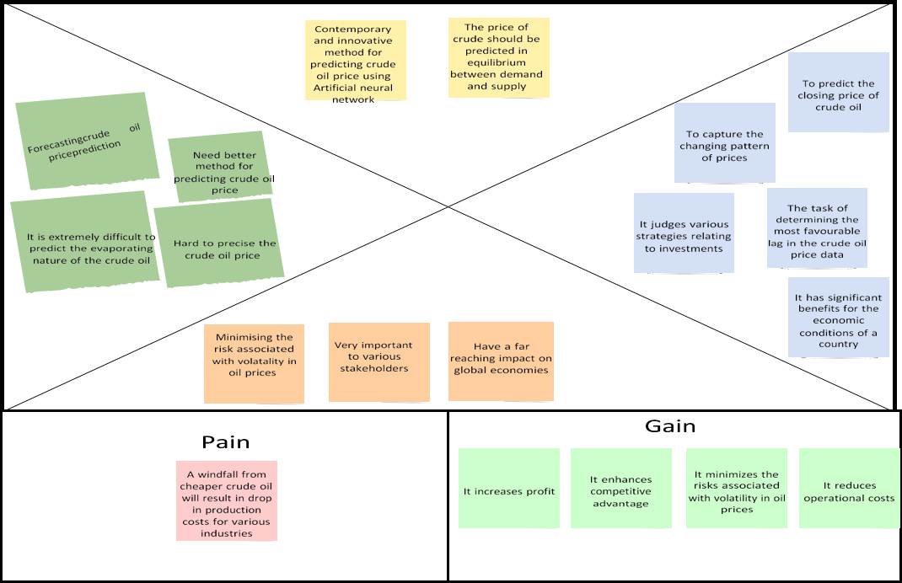

## Ideation & Brainstorming

Brainstorming provides a free and open environment that encourages everyone within a team to participate in the creative thinking process that leads to problem solving. Prioritizing volume

over value, out-of-the-box ideas are welcome and built upon, and all participants are encouraged to collaborate, helping each other develop a rich number of creative solutions.

Step-1: Team Gathering, Collaboration and Select the Problem Statement

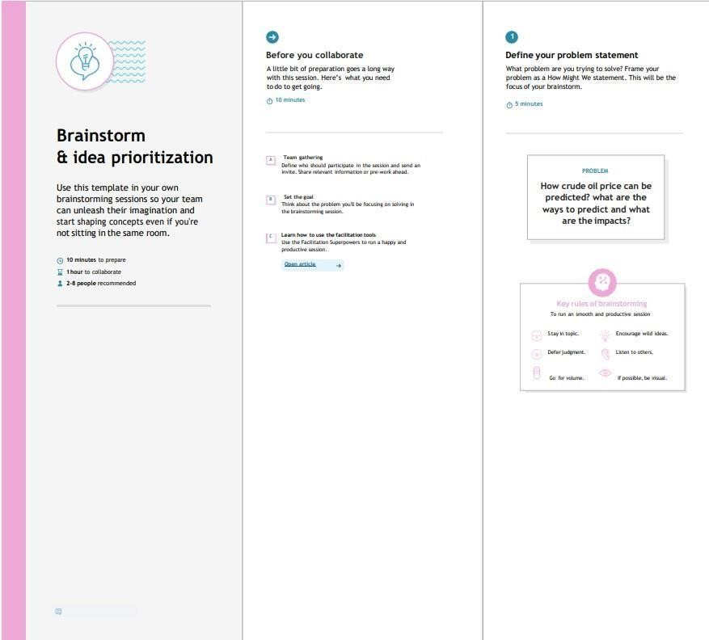

Step-2: Brainstorm, Idea Listing and Grouping

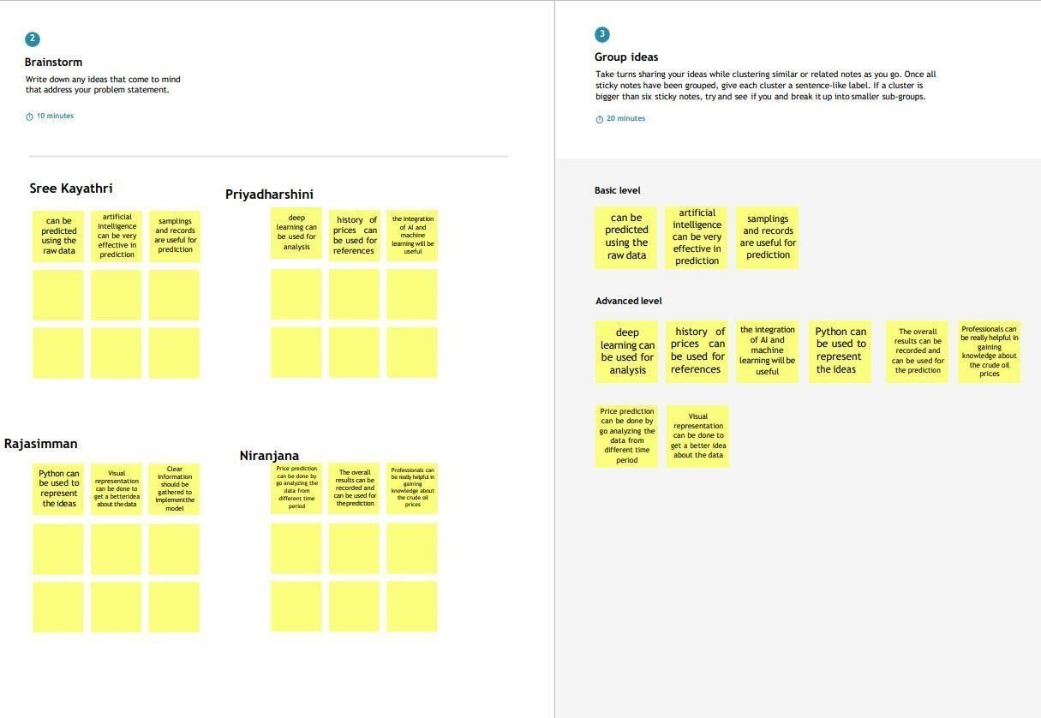

Step-3: Idea Prioritization

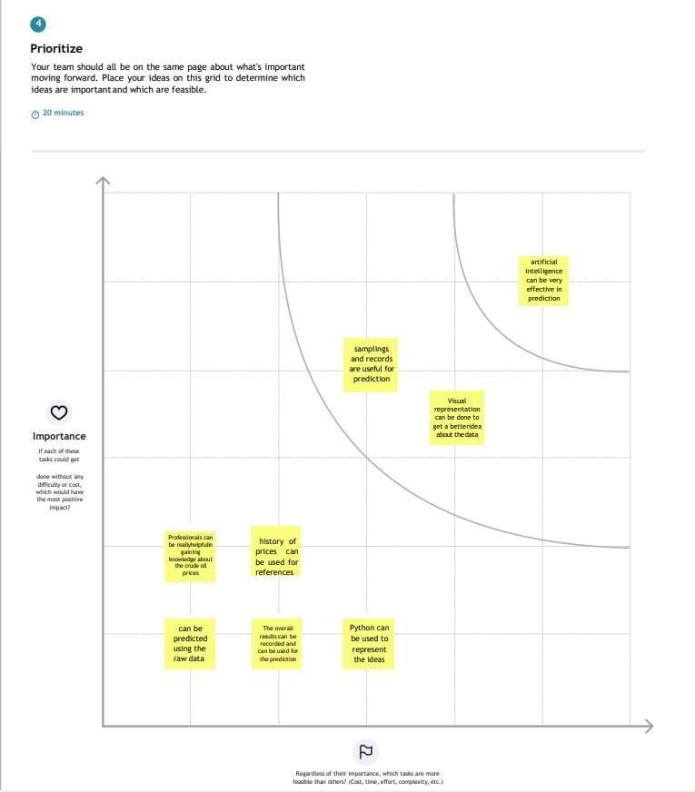

## Proposed Solution

The project team shall fill in the following information in the proposed solution template.

|  |  |  |
| --- | --- | --- |
| **S.No** | **Parameter** | **Description** |
| 1. | Problem Statement (Problem to be solved) | As with the erratic changes in supply and demand and the influence of geopolitics, it is very hard to predict the value of crude oil prices in the global market. |
| 2. | Idea / Solution description | We are going to collect the dataset of the past oil prices with time so that by feeding those to the model and training it and compiling it and when it is achieved the optimal state we can implement it in the web application. |
| 3. | Novelty / Uniqueness | It may be a traditional idea but the implementation of periodic training will have a better effect on it. |
| 4. | Social Impact / Customer Satisfaction | By using the web app customer can gain knowledge of the crude oil price and get benefits financially. |
| 5. | Business Model (Revenue Model) | It will be used by every individual at ease so that they can have an idea of the crude price so, that the use of the crude will be stable in the market |
| 6. | Scalability of the Solution | The idea we proposed it take the input in the periodic and adjust and train through these so, that it will adapt to very different situations. |

* 1. Problem Solution fit

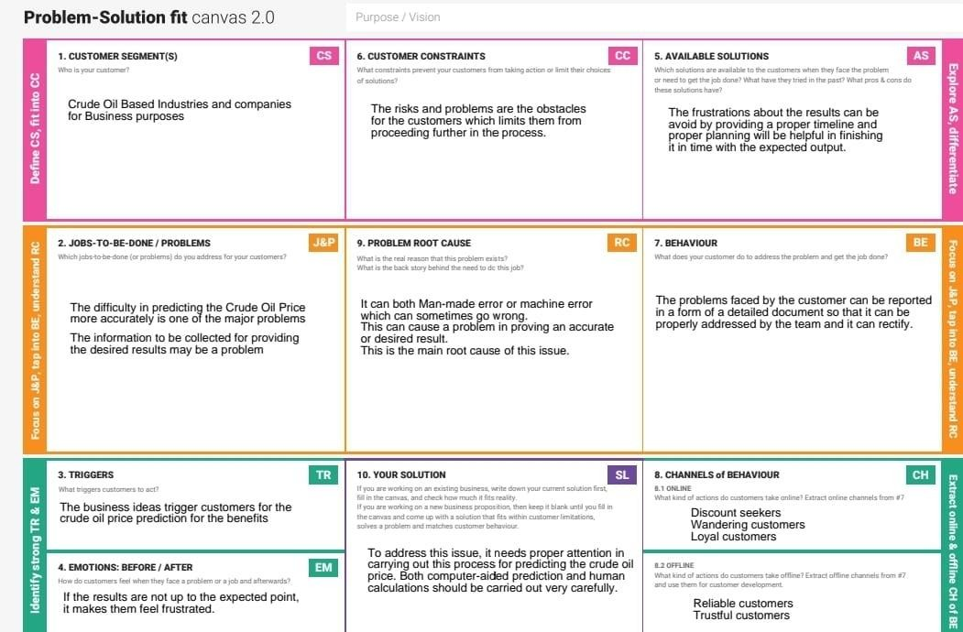

# REQUIREMENT ANALYSIS

## Functional requirement

Following are the functional requirements of the proposed solution.

|  |  |  |
| --- | --- | --- |
| **FR No.** | **Functional Requirement**  **(Epic)** | **Sub Requirement (Story / Sub-Task)** |
| FR-1 | User Application | User Direct Open with Google Play Store App User  Can Download the Crude Oil Price. |
| FR-2 | User Products Available | User Using the Application There Are So Many Products in Crude Oil Price App.  User Update the Energy and Oil Price Instant in the  Application. |
| FR-3 | User Additional Features | User Can Read Latest News and View Oil Price Charts. User View Major Energy Quotes.  User Can Using a Multiple Color Themes. |
| FR-4 | User Exceptions | User Can Exchange Rates and Currency Converter. |
|  |  |  |

## Non-Functional requirement

Following are the non-functional requirements of the proposed solution.

|  |  |  |
| --- | --- | --- |
| **FR No.** | **Non-Functional Requirement** | **Description** |
| NFR-1 | Usability | Used to improve to the Accuracy of crude oil  price prediction. |
| NFR-2 | Security | In the rising oil price can even shift economical/political power from oil importers to oil exporters communications will be  secured. |
| NFR-3 | Reliability | Reliability of the pointing towards high –risk  components. |
| NFR-4 | Performance | Performance of this project is to improve to the  accuracy of crude oil price prediction. |
| NFR-5 | Availability | The Availability Solution is More Benefit for and the Importers and exporters in the crude oil  price prediction. |
| NFR-6 | Scalability | The scalability is 90%-95%. |

# PROJECT DESIGN

## DATA FLOW DIAGRAMS

DATA FLOW DIAGRAM:

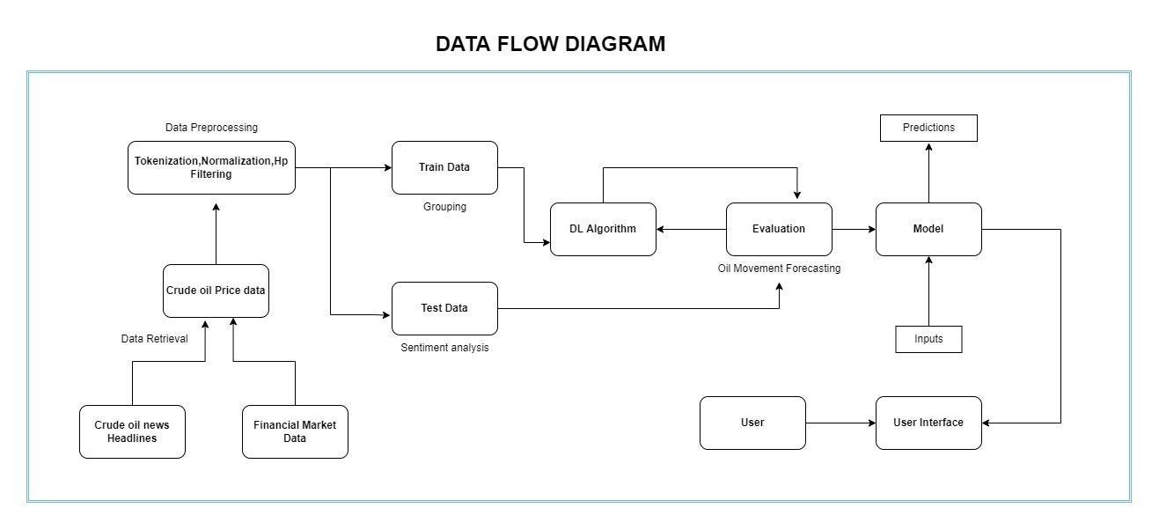A Data Flow Diagram (DFD) is a traditional visual representation of the information flows within a system. A neat and clear DFD can depict the right amount of the system requirement graphically. It shows how data enters and leaves the system, what changes the information, and where data is stored

## SOLUTION & TECHNICAL ARCHITECTURE

Solution Architecture:

Solution architecture is a complex process – with many sub-processes – that bridges the gap between business problems and technology solutions. Its goals are to:

* Find the best tech solution to solve existing business problems.
* Describe the structure, characteristics, behaviour, and other aspects of the software to project stakeholders.
* Define features, development phases, and solution requirements.
* Provide specifications according to which the solution is defined, managed, and delivered

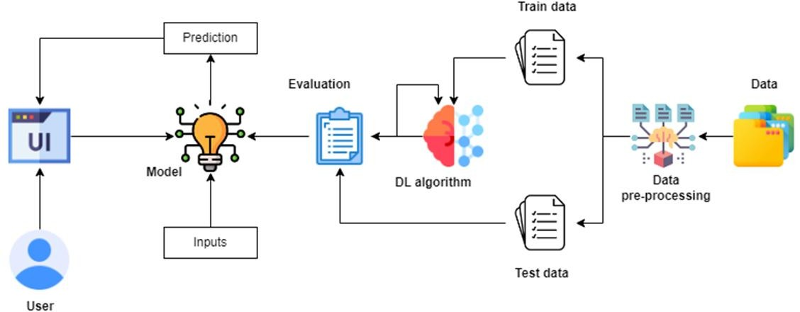

## USER STORIES

**User Stories**

Use the below template to list all the user stories for the product.

|  |  |  |  |  |  |  |
| --- | --- | --- | --- | --- | --- | --- |
| **User Type** | **Functional Requirement**  **(Epic)** | **User Story Number** | **User Story/ Task** | **Acceptance criteria** | **Priority** | **Release** |
| Customer (Mobile User) | Registration | USN-1 | As a user,I can register for the application by  entering my email, password,and confirming my password. | I can access my account/ Displays Line gragh / Bar gragh. | High | Sprint-1 |
|  |  | USN-2 | As a user,I will receive confirmation email once I have registered for the application | I can receive confirmation email & click confirm | High | Sprint-1 |
|  |  | USN-3 | As a user,I can register for the application through Facebook | I can register & accessthe my Account | Low | Sprint-2 |
|  |  | USN-4 | As a user,I can register for the application through Gmail | I can register through already logged in gmail account. | Medium | Sprint-1 |
|  | Login | USN-5 | As a user,I can log into the application by entering email & password | After registration,I can log in by only email & password. | High | Sprint-1 |
|  | Line\Bar gragh |  | After entering the inputs,the model will display predictions in Line\Bar Gragh Format. | I can get the expected prediction in various formats. | High | Sprint-3 |
| Customer (Web user) | Login | USN-1 | As the web user,I can login simply by using Gmail or Facebook account. | Already created gmail can be used for Login. | Medium | Sprint-2 |
| Customer Care Executive | Support |  | The Customer care service will provide solutions for any FAQ and also provide ChatBot. | I can solve the problems arised by Support. | Low | Sprint-3 |
| Administrator | News |  | Admin will give the recent news of Oil Prices. | Provide the recent oil prices. | High | Sprint-4 |
|  | Notification |  | Admin will notify when the oil prices changes. | Notification by Gmail. | High | Sprint-4 |
|  | Access Control |  | Admin can control the access of users. | Access permission for Users. | High | Sprint-4 |
|  | Database |  | Admin can store the details of users. | Stores User details. | High | Sprint-4 |

1. PROJECT PLANNING AND SCHEDULING

## 6.1 & 6.2 Sprint Planning, Estimation and Delivery Schedule

### Product Backlog, Sprint Schedule, and Estimation

Use the below template to create product backlog and sprint schedule

|  |  |  |  |  |  |  |
| --- | --- | --- | --- | --- | --- | --- |
| **Sprint** | **Functional Requirement**  **(Epic)** | **User Story**  **Number** | **User Story / Task** | **Story Points** | **Priority** | **Team Members** |
| Sprint- 1 | Registration | USN-1 | As a user, I can register for the application by entering my email, password, and confirming my  password. | 10 | High | D.Harshitha Reddy |
| Sprint- 1 |  | USN-2 | As a user, I will receive confirmation email once I have registered for  the application | 10 | High | B .Harshini |
| Sprint- 1 | Login | USN-3 | As a user, I can log into the application by entering email &  password. | 15 | High | P . Abitha |
| Sprint- 2 | Input Necessary Details | USN-4 | As a user, I can give Input Details to Predict Likeliness of  crude oil | 15 | High | Ila Choudary . A |
| Sprint- 2 | Data Pre- processing | USN-5 | Transform raw data into suitable format for  prediction. | 15 | High | B .Harshini |
| Sprint-3 | Prediction of Crude Oil  Price | USN-6 | As a user, I can predict Crude oil | 20 | High | Ila Choudary.A |

|  |  |  |  |  |  |  |
| --- | --- | --- | --- | --- | --- | --- |
|  |  |  | using machine  learning model. |  |  |  |
| Sprint-3 |  | USN-7 | As a user, I can get accurate prediction of  crude oil | 5 | Medium | P . Abitha |
| Sprint-4 | Review | USN-8 | As a user, I can give feedback of  the application. | 20 | High | D.Harshitha Reddy |

|  |  |  |  |  |  |  |  |  |
| --- | --- | --- | --- | --- | --- | --- | --- | --- |
| **Sprint** | **Total Story Points** | **Duration** | **Sprint Start Date** | | **Sprint End Date (Planned)** | | **Story Points Completed (as on Planned**  **End Date)** | **Sprint Release Date (Actual)** |
| Sprint-1 | 20 | 6 Days | 24  2022 | Oct | 29 Oct 2022 | | 20 | 29 Oct 2022 |
| Sprint-2 | 20 | 6 Days | 31  2022 | Oct | 05  2022 | Nov |  |  |
| Sprint-3 | 20 | 6 Days | 07  2022 | Nov | 12  2022 | Nov |  |  |
| Sprint-4 | 20 | 6 Days | 14  2022 | Nov | 19  2022 | Nov |  |  |
|  |  |  |  | |  | |  |  |
|  |  |  |  | |  | |  |  |
|  |  |  |  | |  | |  |  |
|  |  |  |  | |  | |  |  |

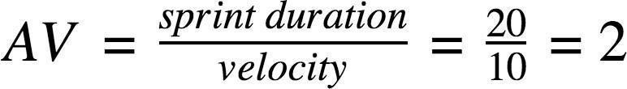

### Velocity:

Imagine we have a 10-day sprint duration, and the velocity of the team is 20 (points per sprint).

Let’s calculate the team’s average velocity (AV) per iteration unit (story points per day)

**Burndown Chart:**

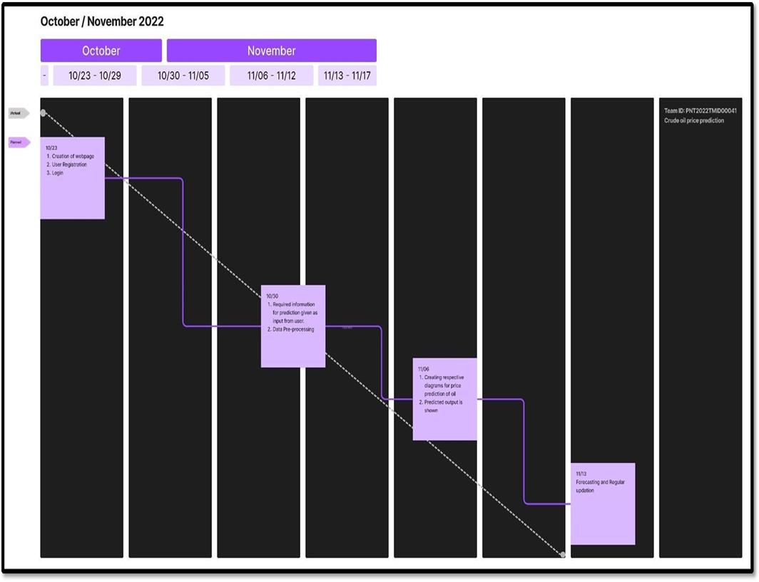

# Coding and Solutioning

## Features

Feature Scaling

Feature scaling is a method used to normalize the range of independent variables or features of data.

The next step is to scale the crude oil prices between (0, 1) to avoid intensive computation. Common methods include **Standardization** and **Normalization**.

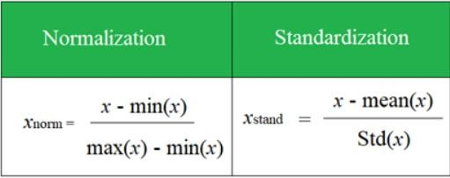

## Feature 2

STM's are sensitive to the scale of the data so we apply MinMax scaler.

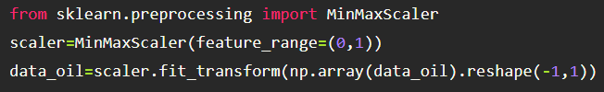

# Testing

## Test cases



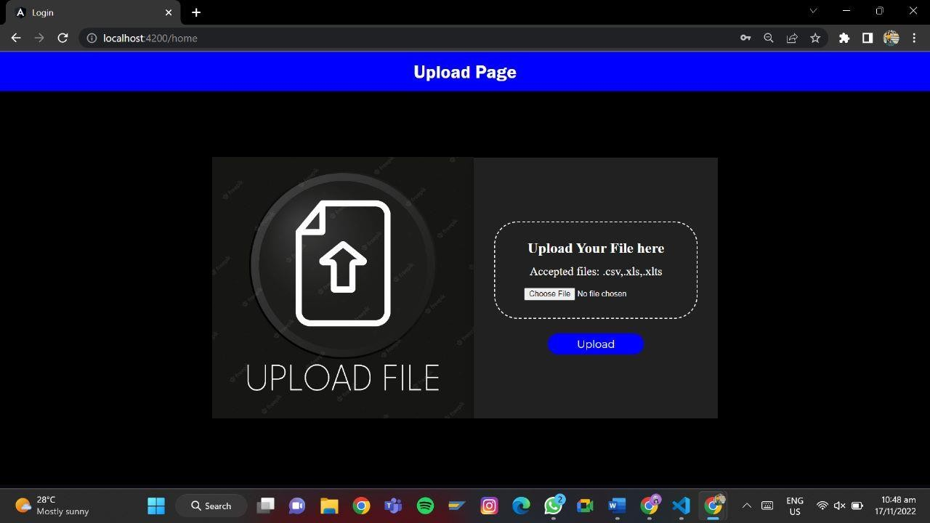

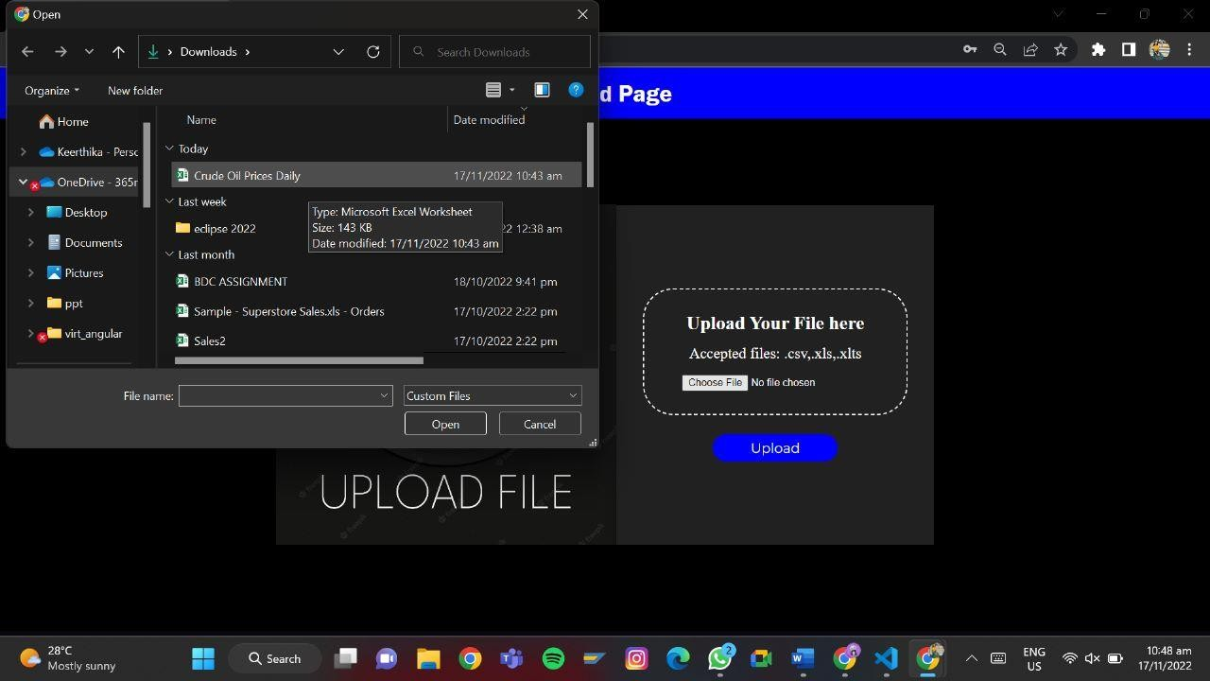

* 1. User Acceptance Testing

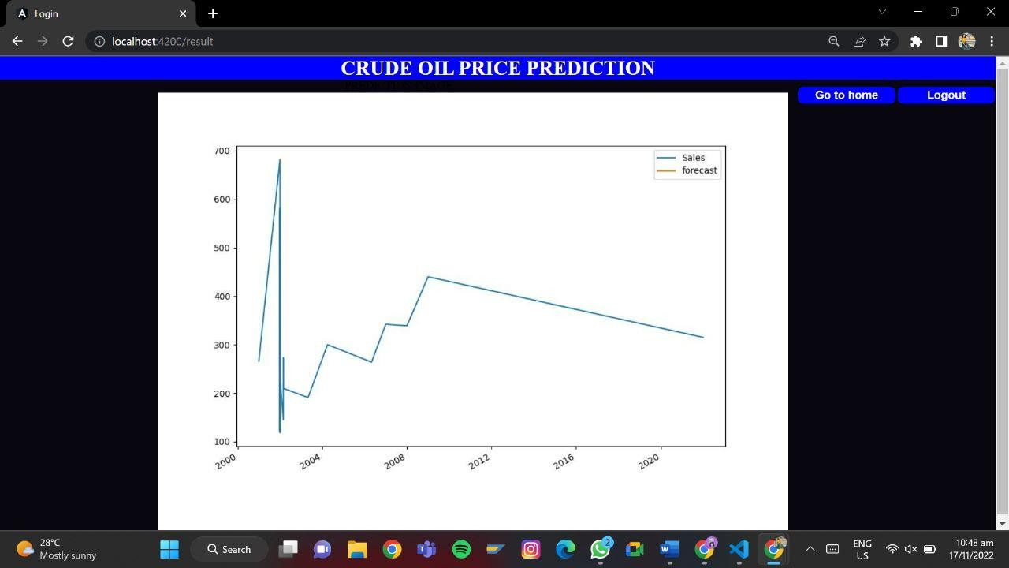

# RESULTS

## PERFORMANCE METRICS

performance metrics, the mean absolute error (MAE) and the root mean square error (RMSE) which have been frequently used in previous studies (e.g., Tang et al. 2015; Lerner and Seru 2021), formulated as:

MAE=1T2−1∑t=T1+2T1+T2|yt−y^t|RMSE=1T2−1∑t=T1+2T1+T2(yt−y^t)2−−−−−−−−−−−−−−−−−−

Performance evaluation metrics

In order to evaluate the one-step prediction performance of the models from comprehensive respects, we select two conventional



⎷

where T1 and T2 are the length of the training and testing set respectively, and yt and yˆt are the actual and predicted returns on real oil price. Obviously, smaller MAE and RMSE indicate a better prediction model.

In addition, we use another popular evaluation metric, the out-of-sample R-squared, i.e., R2OOS, which compares different forecast approaches with a benchmark model. In this paper, we use the random walk model as benchmark, which is solidly based on the Efficiency Market Hypothesis (EMH), and consequently, the R2OOS statistic is defined as:

R2OOS=100×[1−∑T1+T2t=T1+2(yt−y^t)2∑T1+T2t=T1+2(yt−y^RWt)2]

where the yˆRWt is the random walk predictions. The R2OOS measures the performance of candidate prediction approach relative to the trivial prediction, hence a higher and positive R2OOS indicates a better accuracy of forecasting, compared with the benchmark as R2OOS=0. For the evaluation of return prediction, the information coefficient (IC) has been widely adopted in prior studies, see for example Guerard et al. (2021). The IC describes the correlation between the predicted and realized asset returns as:

IC=corr(yt,y^t)

where y^t is the return forecast and yt is the actual return. The IC is calculated on the testing set. Undoubtedly, higher ICs indicate a better prediction.

Change points detected within the predictor panel

We perform the first module of the proposed CP-ADARNN framework to detect the common breaks in the mean of the predictors (non-normalized) following Horváth et al. (2021c). As discussed in Subsect. 3.2, we apply the change-in-mean test based on the detection statistic vN,T for the high-dimensional cross-dependent panel. To accommodate potential multiple changes, a binary segmentation method is used in the fixed sample of the training set. Accordingly, we find the first and largest change in the predictors structure as October 2007 which divides the whole training sample into two parts—from March 1993 to October 2007 (176 monthly observations) and from November 2007 to February 2016 (100 monthly observations). In addition, two sub-period changes are detected in April 2000 and December 2009.

1. ADVANTAGES AND DISADVANTAGES

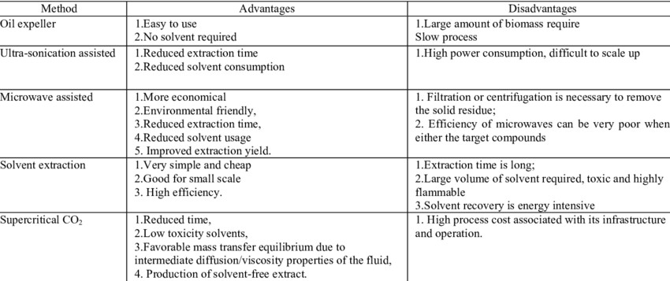

# 11&12 Conclusion and Future Scope

In this paper, an artificial neural network model is presented with the task of determining the most favourable lag

in the crude oil price data. It is evident, the result is shown in the figure, the prediction is accurate till there is a

massive and sudden change in the actual data, where it becomes challenging to predict the exact new price with

the change, however, the proposed model has efficiently taken into consideration these patterns. Else ways, this

also proves the theory that financial markets are unpredictable and change anytime because of known and unknown

factors[13]. This work indicates that the ANN model is an effective tool for crude oil price prediction and can be

efficiently used for short term price forecasting by determining the optimal lags. The proposed model is powerful

and highly suggested because investors can use it not only to initiate trades but also as an effective tool to judge

various strategiesrelating to investments. This work is carried out on the closing price of crude oil; however, there are various other factors

which also affect the crude oil prices like change in the prices and quantities (demand and supply), change in the

economy and current affairs as shown by the media. The main advantage of this research is in capturing the changing

pattern of these prices. In the coming future, fundamental indicators and market trends have been planned to be

incorporated into a model which will help the proposed model perform more efficiently.

# 13.Appendix

## 13.1 Source Code

<!DOCTYPE html>

<!-- saved from url=(0139)https://github.com/IBM-EPBL/IBM-Project-19513- 1659698882/blob/main/Project%20Development%20Phase/Sprint%204/showcasing_price_pr ediction.jpg -->

<html lang="en" data-color-mode="auto" data-light-theme="light" data-dark-theme="dark" data-a11y-animated-images="system" data-turbo-loaded=""><head><meta http- equiv="Content-Type" content="text/html; charset=UTF-8"><style type="text/css">.turbo- progress-bar {

position: fixed; display: block; top: 0;

left: 0; height: 3px;

background: #0076ff; z-index: 2147483647; transition:

width 300ms ease-out, opacity 150ms 150ms ease-in; transform: translate3d(0, 0, 0);

}

</style>

<link crossorigin="anonymous" media="all" rel="stylesheet" href="./python_code_files/light- 719f1193e0c0.css"><link crossorigin="anonymous" media="all" rel="stylesheet" href="./python_code_files/dark-0c343b529849.css"><link data-color-theme="dark_dimmed" crossorigin="anonymous" media="all" rel="stylesheet" data- href="https://github.githubassets.com/assets/dark_dimmed-f22da508b62a.css"><link data- color-theme="dark_high_contrast" crossorigin="anonymous" media="all" rel="stylesheet" data-href="https://github.githubassets.com/assets/dark_high_contrast-

188ef1de59e6.css"><link data-color-theme="dark_colorblind" crossorigin="anonymous" media="all" rel="stylesheet" data- href="https://github.githubassets.com/assets/dark_colorblind-bc6bf4eea850.css"><link data- color-theme="light_colorblind" crossorigin="anonymous" media="all" rel="stylesheet" data- href="https://github.githubassets.com/assets/light_colorblind-527658dec362.css"><link data- color-theme="light_high_contrast" crossorigin="anonymous" media="all" rel="stylesheet" data-href="https://github.githubassets.com/assets/light_high_contrast- c7a7fe0cd8ec.css"><link data-color-theme="light_tritanopia" crossorigin="anonymous" media="all" rel="stylesheet" data- href="https://github.githubassets.com/assets/light_tritanopia-6aa855bdae0f.css"><link data- color-theme="dark_tritanopia" crossorigin="anonymous" media="all" rel="stylesheet" data- href="https://github.githubassets.com/assets/dark_tritanopia-6aa5e25aacc0.css">

<link crossorigin="anonymous" media="all" rel="stylesheet" href="./python_code_files/primer-f9c4f0f1debb.css">

<link crossorigin="anonymous" media="all" rel="stylesheet" href="./python_code_files/global-fbcd8ad98877.css">

<link crossorigin="anonymous" media="all" rel="stylesheet" href="./python_code_files/github-5d7162839c37.css">

<link crossorigin="anonymous" media="all" rel="stylesheet" href="./python_code_files/code- 096ebcd52499.css">

<script crossorigin="anonymous" defer="defer" type="application/javascript" src="./python_code_files/wp-runtime-8e2c2a015b68.js.download"></script>

<script crossorigin="anonymous" defer="defer" type="application/javascript" src="./python_code_files/vendors-node_modules_manuelpuyol_turbo_dist_turbo_es2017- esm_js-af11d99b3e65.js.download"></script>

<script crossorigin="anonymous" defer="defer" type="application/javascript" src="./python_code_files/vendors-node_modules_stacktrace-parser_dist_stack-trace- parser_esm_js-node_modules_github_bro-d351f6-c1d63d230b29.js.download"></script>